**1-2 notes**

**GeoJSON and Leaflet Plugins**

Module 15.2

Goals:

* Produce heat maps, marker clusters, and choropleth maps using third-party Leaflet.js plugins.
* Research how to use additional third-party Leaflet.js plugins and JavaScript libraries.
* Differentiate between maps and map elements for visualizing different datasets.
* Create and deploy custom interactive dashboards.

**GeoJSON** is an open-standard format for representing simple geographical features along with their nonspatial attributes by using JavaScript Object Notation (JSON).

**Create a GeoJSON layer**

* We pass all the earthquake feature data to the L.GeoJSON method.
* We save its return value (which is the new Leaflet GeoJSON layer) in the earthquakes variable.

**onEachFeature Function**

* During layer creation, Leaflet supplies a built-in hook named onEachFeature.
* We can define a function that performs custom functionality with the addition of each feature object to the GeoJSON layer.
* In this case, we give each layer a tooltip with the time and location of the earthquake.

**Basic NYC boroughs solution:**

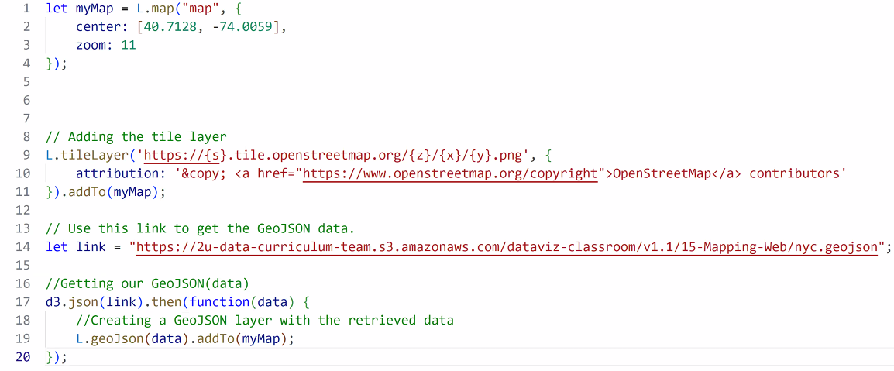

Logic 4:

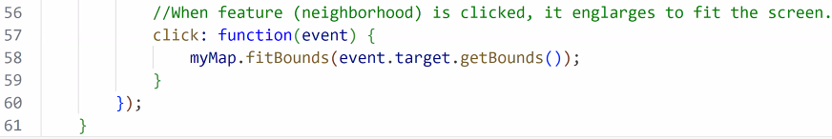

**Review NYC boroughs and Australia Hydrants once solution is posted with URL to get the json from.**

**Do activity 3 Stu Marker Clusters on your own as prep for Thursday’s class.**

